Retailer Adoption of Upcycled Food Products: Evidence from Food Retailers in Coimbatore City
Research Gap
Upcycled food products are increasingly recognised as a sustainable solution to reduce food waste and promote circular economy practices. Upcycled food products are developed by using surplus or by-product ingredients from food production that are still safe for consumption, with the aim of reducing food waste and promoting sustainable food systems. However, most existing studies focus on consumer perspectives and environmental benefits, while very limited research has examined retailers’ views, even though retailers decide whether such products are stocked and reach the market. There is a lack of clear understanding of the business concerns and practical challenges that influence retailers’ willingness to stock upcycled food products, particularly in emerging market contexts.
Research Questions
- What is the level of awareness of upcycled food products among food retailers?
- What commercial and operational factors influence retailers’ willingness to stock upcycled food products?
- How does perceived consumer acceptance affect retailers’ willingness to stock upcycled food products?
Objectives of the Study
- To assess the level of awareness of upcycled food products among food retailers.
- To identify the key commercial and operational factors influencing retailers’ willingness to stock upcycled food products.
- To examine the influence of perceived consumer acceptance on retailers’ willingness to stock upcycled food products.
Methodology
The study employs a descriptive-analytical research design to examine retailers’ willingness to stock upcycled food products. The study area includes selected urban food retail outlets, such as supermarkets, organic stores, and Kirana stores. A purposive sampling technique was used to select retailers directly involved in packaged food stocking decisions.
Primary data were collected using a structured questionnaire administered to retailers. The questionnaire consisted of Likert-scale statements designed to capture retailer awareness, perceived consumer acceptance, commercial considerations, operational constraints, and willingness to stock upcycled food products.
The sample size for the seminar study comprised 50-60 retailers.
Variables of the Study
Dependent Variable: Retailers’ willingness to stock upcycled food products
Independent Variables:
- Retailer awareness level
- Perceived consumer acceptance
- Margin expectation
- Shelf-life and food safety concerns
Tools for analysis:
Objective 1
Methodology
- Research design: Descriptive
- Data source: Primary data collected through a structured questionnaire
- Respondents: Food retailers
Tool Used: Percentage Analysis
- To identify the proportion of retailers who are aware, partially aware, or unaware of upcycled food products
- To clearly present awareness levels in simple percentage form
Objective 2
Methodology
- Research design: Descriptive and analytical
- Data source: Primary data collected using Likert-scale statements
- Respondents: Food retailers
Tool Used: Mean Score Analysis
- To rank the business and operational factors influencing retailers’ stocking decisions
- To identify the most and least important factors affecting willingness to stock
Objective 3
Methodology
- Research design: Analytical
- Data source: Primary data collected using Likert-scale statements
- Variables considered:
  - Perceived consumer acceptance
  - Retailers’ willingness to stock
Tool Used: Correlation Analysis
- To examine the relationship between perceived consumer acceptance and willingness to stock
- To understand whether higher perceived consumer acceptance leads to higher willingness to stock
Objective 2:
Objective | Construct | Indicator (Measurement Statement) | Supporting Reference (APA style)
Obj. 2 | Commercial Feasibility | Expected profit margin from upcycled food products would be satisfactory | Lin & Chang (2012); Adekunle & Ejechi (2022)
 |  | Sales turnover potential of upcycled food products is promising | Adekunle & Ejechi (2022)
 |  | Price of upcycled food products would be acceptable to customers | Lin & Chang (2012)
 |  | Risk of slow movement or unsold stock is high | Adekunle & Ejechi (2022)
 |  | Promotional and marketing support from brands is necessary | Adekunle & Ejechi (2022)
Obj. 2 | Operational Feasibility | Shelf-life of upcycled food products is suitable for retail sales | Martinez et al. (2018)
 |  | Food safety of upcycled food products is trustworthy | Martinez et al. (2018)
 |  | Packaging quality of upcycled food products is adequate for retail shelves | Martinez et al. (2018)
 |  | Availability of reliable suppliers affects the stocking decision | Lin & Chang (2012)
 |  | Consistency of supply is important for stocking upcycled food products | Lin & Chang (2012)
Obj. 3 | Perceived Consumer Acceptance | Customers are interested in environmentally friendly food products | Martinez et al. (2018)
 |  | Customers are willing to try upcycled food products | Chavan & Akash (2025)
 |  | Customers trust the safety and quality of upcycled food products | Chavan & Akash (2025)
 |  | Customers are likely to repurchase upcycled food products | Lin & Chang (2012)
 |  | Customers are willing to pay for food products with sustainability benefits | Martinez et al. (2018)

References for constructs:
Adekunle, S. A., & Ejechi, J. O. (2022). Modelling new products acceptance among retailers in Nigeria. Journal of Enterprise and Development, 4(1). https://journal.uinmataram.ac.id/index.php/jed/article/view/4947/1971
Chavan, S. S., & Akash, S. B. (2025). Perceptions of retailers towards marketing of organic food products – An empirical study. International Journal of Research in Commerce and Management Studies, 7(3), 496–516. https://www.researchgate.net/publication/393606600
Lin, J.-S. C., & Chang, Y.-C. (2012). Retailers’ new product acceptance decisions: Incorporating the buyer–supplier relationship perspective. Journal of Business & Industrial Marketing, 27(2), 89–99. https://www.researchgate.net/publication/235288874
Martinez, O., Rodriguez, N., Mercurio, A., Bragg, M., & Elbel, B. (2018). Supermarket retailers’ perspectives on healthy food retail strategies and decision making. BMC Public Health, 18, 5917. https://pmc.ncbi.nlm.nih.gov/articles/PMC6097300/

Product list:
- Jackfruit seed flour — made from seeds discarded during jackfruit processing.
- Coconut press-cake flour — from residue after coconut oil extraction.
- Fruit pomace powder (mixed fruit) — dried pulp left after juicing turned into powder.
- Banana peel flour — dried & milled peels from surplus/overripe bananas.
- Overripe banana chips — chips made from bananas rejected for fresh sale.
- Stale cake chips/cake crumbs snacks — crunchy snacks from rescued bakery cake.
- Bread crumb snacks/crackers (from stale bread) — breads rescued and processed into snacks.
- Brewer’s spent grain crackers/biscuits — crackers using spent grain from breweries.
- Spent grain flour — milled brewery by-product used in baking.
- Okara flour/okara cookies — made from soy pulp leftover from tofu/soymilk.
- Mango kernel powder — milled seed kernels from mango processing.
- Tomato pomace powder — dried skins & seeds from tomato paste/juice production.
- Citrus peel powder (orange/lemon) — dried peels from juice processing used as flavor/fiber.
- Pomegranate peel powder — dried peel converted to antioxidant powder.
- Fruit leather/fruit bars (from surplus fruit) — concentrated pastes from imperfect fruit.
- Vegetable peel chips (carrot/okra/beet) — chips from peels/trimmings.
- Pumpkin seed flour — milled seeds left from pumpkin processing.
- Moringa seed cake flour — pressed-cake turned into protein-fortified flour.
- Coffee cherry (cascara) tea — brewed from coffee fruit husk (by-product of coffee bean).
- Spent coffee grounds cookies/bars — baked goods using spent coffee grounds.
- Whey-based beverages/powders — whey from cheese/curd repurposed into drinks or powder.
- Curd whey chivda / snack — savory snacks using dairy whey solids.
- Sugarcane bagasse fiber mixes — fiber ingredient from sugarcane processing by-product.
- Mango seed kernel oilcake flour — oil-extraction residue converted into flour.
- Peanut oilcake protein flour — from peanut oil extraction residue used as protein ingredient.
- Vegetable pulp soup mixes — dehydrated pulps from processing used in instant soups.
- Pickles from grade-out vegetables — pickles made from produce rejected by fresh-market standards.
- Chutneys from overripe fruits — preserves using fruits too soft for fresh sale.
- Fruit pulp yogurt mix — yogurt mix using fruit pulp left from juicing.
- Rice bran edible oil/bran powder — rice milling by-product used as ingredient.
- Idli/dosa batter from excess rice/flour (rescued dough) — rescued batter used in ready mixes.
- Millet/graded-out grain snack mixes — small or broken grains repurposed as mixes.
- Vegetable stem pickles/relishes — pickles made from stems/trimmings (e.g., drumstick stems).
- Onion/garlic peel powder — dried peels milled for flavor/fiber.
- Spice waste blends — leftover spice fragments recombined into blends.
- Eggshell calcium powder (food-grade) — cleaned, processed eggshells used as calcium supplement.
- Whey paneer / ricotta-style products — fresh cheese from whey stream.
- Aquafaba-based products (from chickpea canning liquid) — using legume-cooking liquid as egg replacer.
- Fruit seed oils (e.g., mango kernel oil) — extracted from seeds normally discarded.
- Cereal bran energy bars — bars using bran and milling by-products.
- Sugarcane molasses sweets (from residual molasses) — sweets from processing residues.
- Fish-bone calcium powder (food-grade) — processed small-scale in some local units (where food-safe) — used as mineral supplement.
- Vegetable stalk juice concentrates — juices from stalks trimmed during processing made into concentrates.
- Spice-infused cake/biscuit using surplus milk solids — bakery items using dairy surplus.
- Tomato skin crackers — crackers using dried tomato skins from processing.
- Seed brittle (from oilseed cake) — sweets made from leftover oilseed cakes.
- Imperfect fruit jam/marmalade — jam made from cosmetically imperfect fruit.
- Wheat germ/bran biscuits from milling by-products — biscuits using milling remnants.
- Leftover dal (pulses) powder — from screening/grade-out pulses made into protein mixes.
- Coconut milk residue snacks — using residual solids after coconut milk extraction.
Tamil Nadu Brands:
- Paidhu Ethical Foods is based in Pollachi, Tamil Nadu and sells floral foods (e.g., hibiscus cookies, flower jams).
- Nargunam Foods uses jackfruit, including parts often wasted, to make value-added food items.
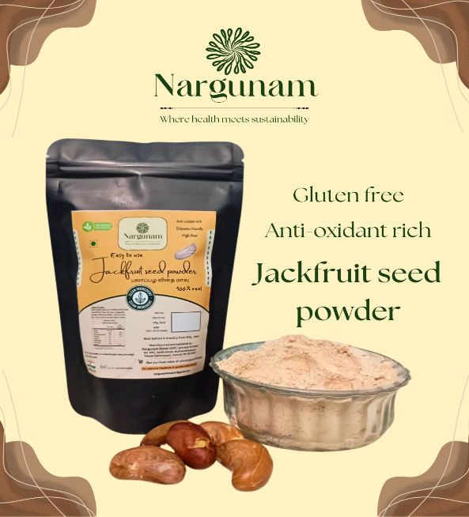
- Banana peel flour products from Ekgaon (or similar online sellers) reuse fruit peels that are typically discarded after eating.
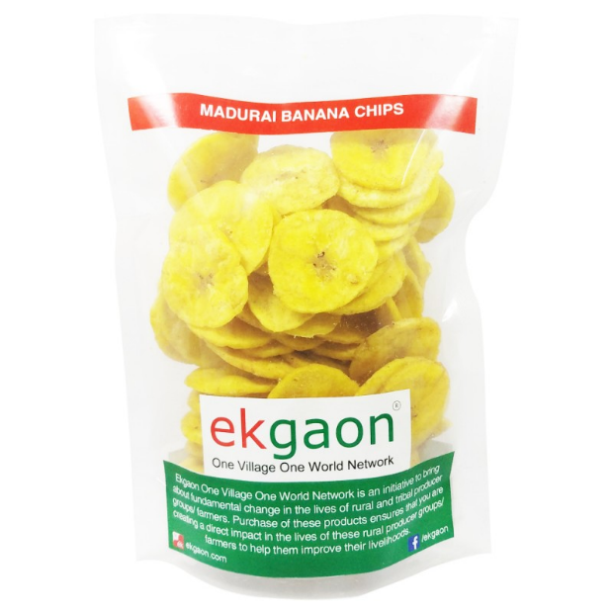
- Brewer’s spent grain-based snacks/flours are produced by several micro-initiatives and are available in the Indian market via e-commerce and artisanal vendors.
International Brands:
- ReGrained – Snack bars and baking mixes made from brewer’s spent grain (a by-product of beer production).
- Renewal Mill – Upcycled flours and baking ingredients made from okara (soy pulp) and other food by-products.
- Barnana – Banana snacks made from “imperfect” or surplus bananas that would otherwise be wasted.
- Pulp Pantry – Vegetable and fruit pulp chips made from juice pulp that would otherwise be discarded.
- RIND Snacks – Upcycled fruit snacks using whole fruit parts (like peels and pulp) that are usually wasted.
- CaPao – Upcycled bites made from cacaofruit (the fruit surrounding cacao beans, often unused).
- Spudsy – Snacks made from “imperfect” sweet potatoes that would otherwise be rejected by conventional supply chains.
- Blue Stripes Urban Cacao – Products deriving value from cacao fruit and shells that are typically discarded.
- Planetarians – Products using brewer’s yeast and oil cakes as upcycled protein ingredients.
- Rubies in the Rubble – Condiments and sauces made from “ugly” or surplus produce that would otherwise be wasted.

Reference for constructs:
Aschemann-Witzel, J., Asioli, D., Banović, M., Perito, M. A., Peschel, A. O., & Others. (2023). Consumer understanding of upcycled foods: Exploring consumer-created associations and concept explanations across five countries. Food Quality and Preference, 112, 105033. https://doi.org/10.1016/j.foodqual.2023.105033
(Use this to justify why upcycled foods require marketing & transparency).
Craig, N., DeHoratius, N., & Raman, A. (2016). The impact of supplier inventory service level on retailer demand. Manufacturing & Service Operations Management, 18(4), 461–474. https://doi.org/10.1287/msom.2016.0582
(Use this to support supplier/supply reliability effects on retailer ordering/stocking).
Aung, M. M., & Chang, Y. S. (2014). Traceability in a food supply chain: Safety and quality perspectives. Food Control, 39, 172–184. https://doi.org/10.1016/j.foodcont.2013.11.007
(Use this to support traceability/transparency as an operational requirement).
Thang, D. C. L., & Tan, B. (2003). Linking consumer perception to preference of retail stores: An S–O–R framework. Journal of Retailing and Consumer Services, 10(2), 73–84. https://doi.org/10.1016/S0969-6989(02)00006-1
(Use this to justify the S-O-R theoretical foundation and retailer cognitive process).
Cox, J. (Year). The effects of in-store marketing tools for the sales of new products [Master’s thesis or working paper]. (Use this and similar studies to justify the marketing/promotional support item). Available: https://arno.uvt.nl/show.cgi?fid=114689.
Rodríguez, B. (2015). Pricing and assortment decisions for a manufacturer selling through a retailer. Journal of Retailing
(Use for category/assortment fit arguments).
Swaraj, A. N. (2025). Sustainable food upcycling: Perspectives on manufacturing and scale (review). Food & Bioproducts.
(Use to support the operational challenges specific to upcycled foods — inconsistent inputs, variability, etc.).

Objective 2 — Commercial Attractiveness (CA)
CA1: Expected profit margin from upcycled products is satisfactory
- Support: Ailawadi & Keller style retail/new-product profitability literature; general NPI and assortment literature. Use Rodríguez (2015) for retail price/assortment arguments.
- How to present: Adapted from retail assortment/pricing literature (Rodríguez, 2015).
CA2: Sales turnover potential is promising
- Support: New product introduction and trial literature; in-store promotion studies show turnover effects on retailer d
Questionnaire
.
- Presentation: Adapted from studies on new product trial and turnover (Cox, 201? / Rodríguez, 2015).
CA3: Product price will be acceptable to customers
- Support: Pricing & consumer willingness to pay for sustainability (Aschemann-Witzel, 2023; upcycled consumer willingness literature).
- Presentation: Adapted from consumer willingness studies on upcycled/sustainable food (Aschemann-Witzel et al., 2023).
CA4: Risk of slow movement or unsold stock for upcycled food products is high (reverse coded)
- Support: Inventory/shelf-space risk literature; Craig et al. (2016) shows suppliers’ service levels affect retailer demand and assortment (use to justify risk).
- Presentation: Adapted — justified by supplier/inventory & assortment literature (Craig et al., 2016).
CA5: Visible consumer-facing marketing (brand campaigns, in-store promotions, POS materials) from suppliers is necessary for me to confidently stock upcycled food products. (your CF5 final wording)
- Support: In-store promotion and retail merchandising literature; Cox (in-store promotions), and literature on new product success driven by promotional support.
- Presentation: Adapted from promotional support / new product adoption literature (Cox, 2012; Wang, 2023).
Objective 2 — Operational Viability (OF)
OF1: Shelf-life of upcycled food products is suitable for retail sales
- Support: Food safety & shelf-life importance in novel foods; traceability & safety literature (Aung & Chang, 2014).
- Present as: Adapted from food safety & shelf-life literature (Aung & Chang, 2014).
OF2: Food safety of upcycled food products is trustworthy
- Support: Upcycled food consumer perception and safety concerns — Aschemann-Witzel (2023); traceability & food safety literature.
- Present as: Adapted from upcycled food perception and traceability literature.
OF3: Packaging quality of upcycled food products is adequate for retail shelves
- Support: Packaging as a retail cue and safety/quality communication (traceability & packaging studies). Aung & Chang (2014) and packaging + trust literature.
- Present as: Adapted from packaging & product quality cues literature.
OF4 (merged): Reliable suppliers with consistent supply are essential for stocking upcycled food products.
- Support: Craig, DeHoratius & Raman (2016) — supplier service level impacts retailer demand; also general supply reliability literature.
- Present as: Adapted from supplier inventory service level literature (Craig et al., 2016). — this is not an invented idea; it is well supported.
OF5 (new, upcycled-specific): Clear information about the source and processing of upcycled ingredients is important for stocking these products.
- Support: Traceability and transparency literature (Aung & Chang, 2014; Gupta, 2023; consumer traceability trust). Aschemann-Witzel (2023) also documents consumer concerns and the need to explain upcycled processes.
- Present as: Adapted from traceability and upcycled food literature.
Objective 3 — Perceived Consumer Demand (PCD) — Retailer-perceived consumer acceptance
PCD1: Customers understand the concept of upcycled food
- Support: Aschemann-Witzel (2023) documents varied consumer understanding and associations. Use that to justify retailer-reported understanding.
- Present as: Adapted from consumer understanding studies (Aschemann-Witzel et al., 2023).
PCD2: Customers are willing to try upcycled food products
- Support: Empirical willingness-to-try studies for novel foods and upcycled products (e.g., Coderoni & Perito; Aschemann-Witzel).
- Present as: Adapted from willingness-to-try literature.
PCD3: Customers trust the safety and quality of upcycled food products
- Support: Consumer trust & traceability literature (Wu et al., 2021; Aung & Chang, 2014).
- Present as: Adapted from trust & traceability research.
PCD4: Customers are likely to repurchase upcycled food products
- Support: Repeat-purchase intention research for sustainable foods; upcycled food studies that examine repurchase/loyalty (Aschemann-Witzel; Coderoni & Perito).
- Present as: Adapted from studies on repurchase intent for sustainable/novel foods.
PCD5: Customers are willing to pay for food products with sustainability benefits
- Support: Willingness to pay (WTP) studies in sustainable food literature; cite Aschemann-Witzel (2023) and related WTP studies.
- Present as: Adapted from WTP and sustainable consumption literature.

Retailers’ Willingness to Stock (RWS)
RWS1: I am willing to stock upcycled food products in my store
RWS2: I would stock upcycled food products if profit margins are comparable
RWS3: I am open to introducing upcycled food products on a trial basis
RWS4: I would continue stocking upcycled food products if customer response is positive
- Support for RWS cluster: New product adoption / retailer decision literature (Rodríguez 2015; Craig et al., 2016; promotional support literature). Use S-O-R to tie constructs → response (Thang & Tan, 2003).

Coimbatore City – Zone-wise Sampling Areas
- West Zone – R.S. Puram
- Central Zone – Race Course
- North Zone – Saibaba Colony
- East Zone – Avinashi Road (within city limits)
- South Zone – Ukkadam
Sampling design:
The study employed a stratified purposive sampling design. Coimbatore city was first stratified into five municipal zones to capture inter-zone variation in retail structure and market characteristics. One representative area was purposively selected from each zone based on observable retail activity, market footfall, and neighborhood profile. The selected areas were R.S. Puram (West Zone), Race Course (Central Zone), Saibaba Colony (North Zone), Avinashi Road within city limits (East Zone), and Ukkadam (South Zone).
Within each selected area, food retail outlets were chosen using purposive sampling. Retailers selling packaged food products and having a minimum of five years of operational experience were included to ensure familiarity with product introduction and stocking decisions. A total of 10 retailers were selected from each area, resulting in an overall sample size of 50 retailers. This sampling approach was considered appropriate for an exploratory seminar study focusing on retailer adoption behavior.

Coimbatore City Zonation:
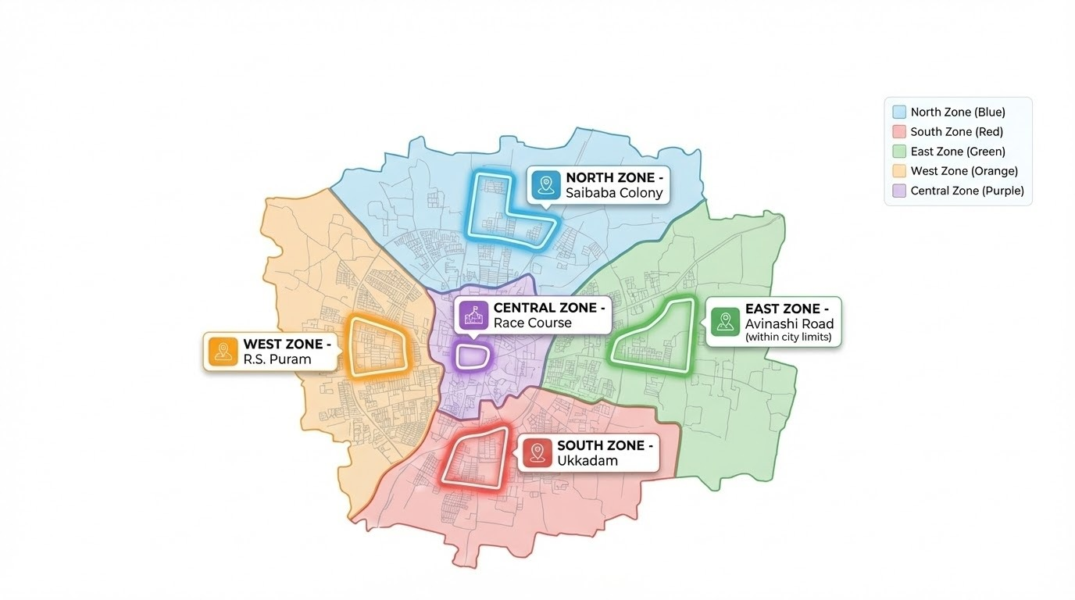

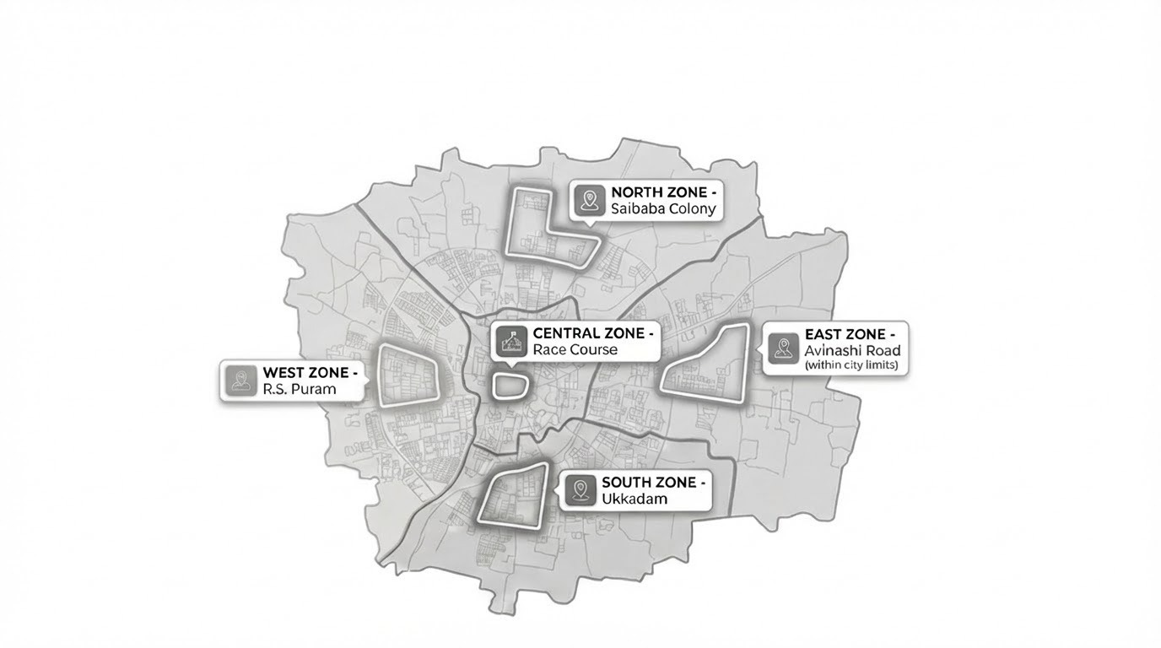

Sampling Flowchart:

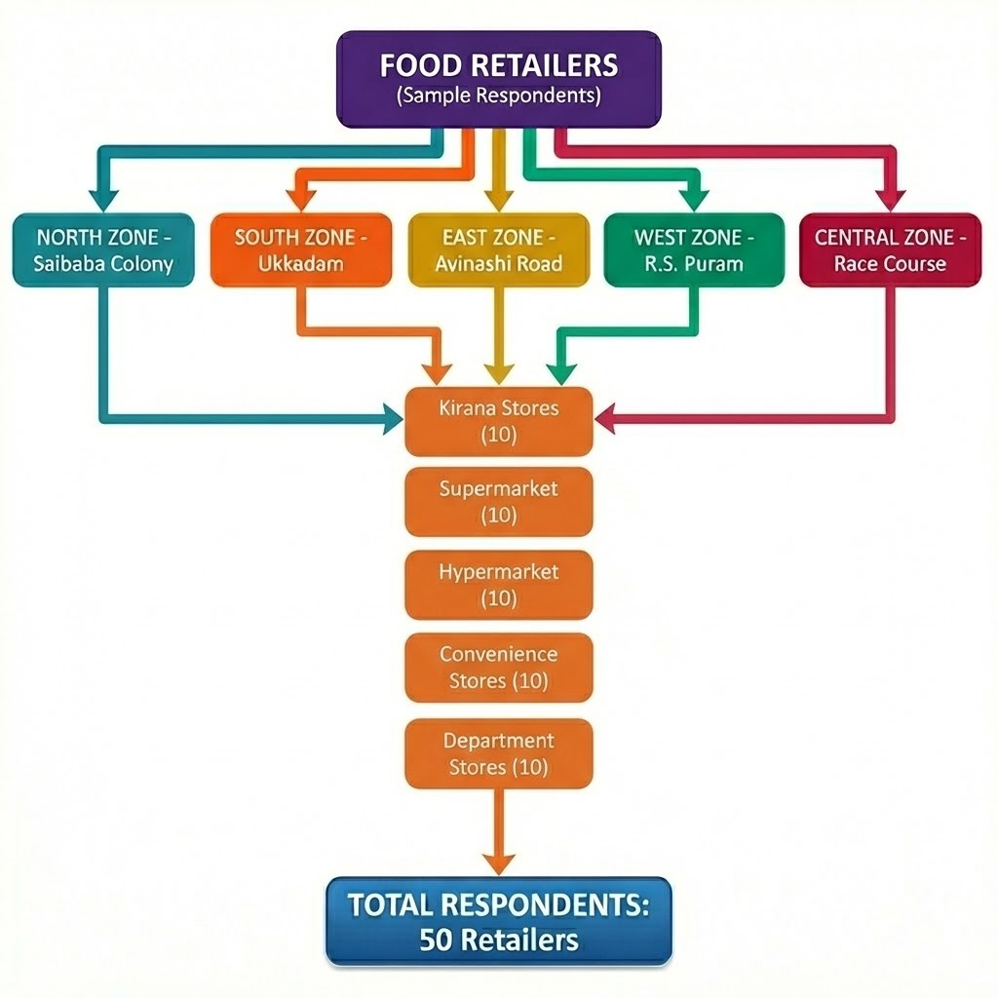

Hypothesis:
H1
Commercial factors of upcycled food products is significantly associated with retailers’ willingness to stock upcycled food products.
H2
Operational factors of upcycled food products is significantly associated with retailers’ willingness to stock upcycled food products.
H3
Retailer-perceived consumer acceptance of upcycled food products is significantly associated with retailers’ willingness to stock upcycled food products.
H4
Commercial factors of upcycled food products is significantly associated with retailer-perceived consumer acceptance.
H5
Operational factors of upcycled food products is significantly associated with retailer-perceived consumer acceptance.
STIMULUS (S)
┌───────────────────────────┐
│ Commercial Attractiveness │
│ Operational Viability │
└───────────────────────────┘
│ │
│ │
H1, H2 H4, H5
│ │
▼ ▼
┌───────────────────────────┐
│ ORGANISM (O) │
│ Retailer-Perceived │
│ Consumer Acceptance │
└───────────────────────────┘
│
│ H3
▼
┌───────────────────────────┐
│ RESPONSE (R) │
│ Retailers’ Willingness │
│ to Stock Upcycled Foods │
└───────────────────────────┘

Theoretical Framework: Stimulus–Organism–Response (S-O-R) Model
The Stimulus–Organism–Response (S-O-R) framework explains how external stimuli are cognitively processed by decision-makers, resulting in behavioural responses (Mehrabian & Russell, 1974). Originally proposed in environmental psychology, the framework has been widely applied in retail and marketing research to understand how product- and market-related cues influence evaluation and decision outcomes (Turley & Milliman, 2000; Thang & Tan, 2003).
In retail contexts, the S-O-R framework is particularly useful for analysing stocking and adoption decisions, as retailers are exposed to multiple external cues related to product performance, market demand, and operational feasibility before deciding whether to introduce a new product. These external cues serve as stimuli that retailers evaluate internally through cognitive assessments, leading to stocking or adoption decisions (Thang & Tan, 2003).
In this study, the S-O-R framework is applied at the retailer decision-making level to examine the adoption of upcycled food products by retailers in Coimbatore City. Commercial attractiveness and operational viability of upcycled food products are conceptualised as the stimulus (S) components of the framework. Commercial attractiveness includes factors such as expected profit margin, sales turnover potential, price acceptability, perceived risk of slow movement, and availability of marketing support. Operational viability encompasses factors such as shelf life, food safety, packaging adequacy, supplier and supply reliability, and transparency in the sourcing and processing of upcycled ingredients. These factors represent external product- and market-related cues that retailers evaluate before making stocking decisions.
The organism (O) component of the framework is represented by retailer-perceived consumer acceptance of upcycled food products. This construct reflects retailers’ internal cognitive evaluation of how consumers are likely to respond to upcycled food products in terms of interest, trust, willingness to try, repurchase intention, and willingness to pay. Retailers often form such perceptions based on prior market experience, customer interactions, and observed consumer behaviour rather than direct measurement of consumer attitudes (Siegrist & Hartmann, 2020). In the context of upcycled food products, perceived consumer acceptance is particularly important given the novelty of the concept and potential consumer concerns about safety and quality (Aschemann-Witzel et al., 2023).
The response (R) component of the framework is captured by retailers’ willingness to stock upcycled food products, including willingness to introduce them, stock them on a trial basis, and continue stocking them based on customer response. Willingness to stock represents the final behavioural outcome of the retailer’s decision-making process under the S-O-R framework.
Guided by the Stimulus–Organism–Response framework, the present study examines the associations between commercial attractiveness and operational viability (stimuli), retailer-perceived consumer acceptance (organism), and retailers’ willingness to stock upcycled food products (response). The framework provides a coherent theoretical basis for formulating and testing hypotheses related to retail adoption behaviour in the context of upcycled food products, without assuming causal relationships beyond the scope of the study.
References
Aschemann-Witzel, J., Asioli, D., Banović, M., Perito, M. A., Peschel, A. O., & others. (2023). Consumer understanding of upcycled foods: Exploring consumer-created associations and concept explanations across five countries. Food Quality and Preference, 112, 105033. https://doi.org/10.1016/j.foodqual.2023.105033
Mehrabian, A., & Russell, J. A. (1974). An approach to environmental psychology. MIT Press.
Siegrist, M., & Hartmann, C. (2020). Consumer acceptance of novel food technologies. Nature Food, 1(6), 343–350. https://doi.org/10.1038/s43016-020-0094-x
Thang, D. C. L., & Tan, B. (2003). Linking consumer perception to preference of retail stores: An application of the S-O-R framework. Journal of Retailing and Consumer Services, 10(2), 73–84. https://doi.org/10.1016/S0969-6989(02)00006-1
Turley, L. W., & Milliman, R. E. (2000). Atmospheric effects on shopping behavior: A review of the experimental evidence. Journal of Business Research, 49(2), 193–211.

Foundational S-O-R Theory
Mehrabian, A., & Russell, J. A. (1974). An approach to environmental psychology. MIT Press.
(Original S-O-R framework)
Retail application of S-O-R
Thang, D. C. L., & Tan, B. (2003). Linking consumer perception to preference of retail stores: An application of the S-O-R framework. Journal of Retailing and Consumer Services, 10(2), 73–84. https://doi.org/10.1016/S0969-6989(02)00006-1
External cues → retail behaviour
Turley, L. W., & Milliman, R. E. (2000). Atmospheric effects on shopping behavior: A review of the experimental evidence. Journal of Business Research, 49(2), 193–211.
Consumer acceptance as cognitive evaluation
Siegrist, M., & Hartmann, C. (2020). Consumer acceptance of novel food technologies. Nature Food, 1(6), 343–350. https://doi.org/10.1038/s43016-020-0094-x
Upcycled food context
Aschemann-Witzel, J., et al. (2023). Consumer understanding of upcycled foods. Food Quality and Preference, 112, 105033. https://doi.org/10.1016/j.foodqual.2023.105033

